Create a Use Case Diagram
Solution
1. Identify the actors
Understanding the role of each actor within the system and documenting it. Refer to the instructions for Step 2 in the lab instructions.
Actor | Primary/Secondary | Role | Interactions
End Users (Bank Staff) | Secondary | Staff who will eventually use the new systems and dashboards. | Interact with Business Analysts and Systems Architect to provide feedback and requirements for the user-facing aspects of the new systems.

2. Define the use case
List the key use cases for each actor. Refer to the instructions for Step 3 in the lab instructions.
Use case | Description
Manage Customer Account | Actor: End Users (Bank Staff), potentially Project Sponsor, Business Analysts, Product Owners, Compliance Officers.  Description: The system allows authorized bank staff to view, update, and manage customer account details (e.g., personal information, contact details, linked products). It also allows management of account statuses (e.g., active, closed, restricted). This includes tasks like updating beneficiary information, viewing account history summaries, and potentially initiating certain account closure processes (though full closure might involve other use cases).
Use Case 2: Onboard New Customer | Actor: End Users (Bank Staff), potentially Project Sponsor, Business Analysts, Compliance Officers.  Description: The system guides bank staff through the process of collecting required information from a new customer for onboarding. It facilitates the submission and tracking of necessary documentation. The system performs automated checks and validations (e.g., basic identity verification, initial data completeness) and updates the system status to "Onboarding In Progress."

3: Create a use case diagram
Use a diagramming tool, for example, Lucidchart, to create a use case diagram. Refer to the instructions for Step 4 in the lab instructions.
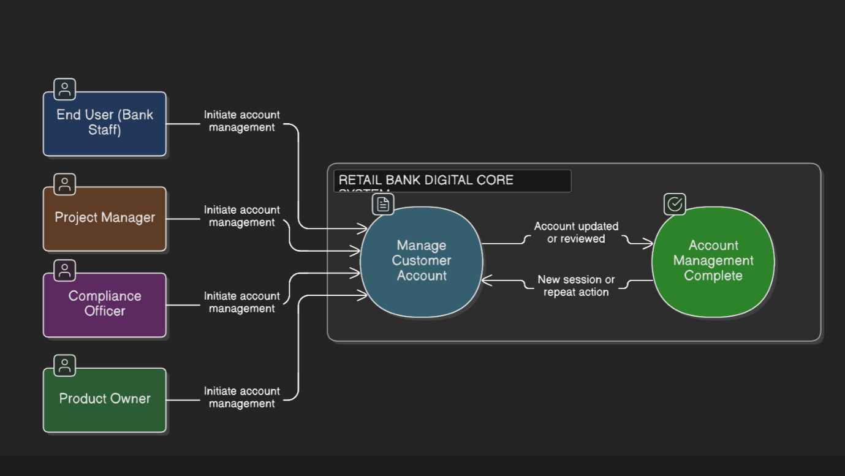

Task 4: Define relationships between actors and use cases
Identify how each actor interacts with the various use cases. Refer to the instructions for Step 5 in the lab instructions.
 |  | Relationship
  Actor
  Use case

Task 5: Answer the following questions for reflection (Optional)
- What challenges did you face when identifying actors and use cases?
in identifying actors
  Challenges
  Description

  Challenges
  in defining use cases
  Description

- How does your diagram facilitate understanding of the program's functionality?
Benefits
  Description

- What are your suggestions for improving customer experience?

 | Description
  Strategies

